# Predicting Personal Loan Approval Using Machine Learning

### 1. INTRODUCTION

### 1.1 overview

A loan is a sum of money that is borrowed and repaid over a period of time, typically with interest. There are various types of loans available to individuals and businesses, such as personal loans, mortgages, auto loans, student loans, business loans and many more.They are offered by banks, credit unions, and other financial institutions, and the terms of the loan, such as interest rate, repayment period, and fees, vary depending on the lender and the type of loan.

A personal loan is a type of unsecured loan that can be used for a variety of expenses such as home repairs, medical expenses, debt consolidation, and more. The loan amount, interest rate,and repayment period vary depending on the lender and the borrower's creditworthiness.To qualify for a personal loan, borrowers typically need to provide proof of income and have a good credit score.

### 1.2 purpose

Predicting personal loan approval using machine learning analyses a borrower's financial data and credit history to determine the likelihood of loan approval. This can help financial institutions to make more informed decisions about which loan applications to approve and which to deny.

### 2. PROBLEM DEFINITION & DESIGN THINKING

### 2.1 Empathy Map

## 

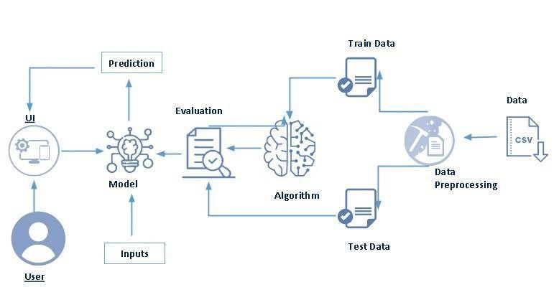

**2.2 IDEATION & BRAINSTROMING MAP**

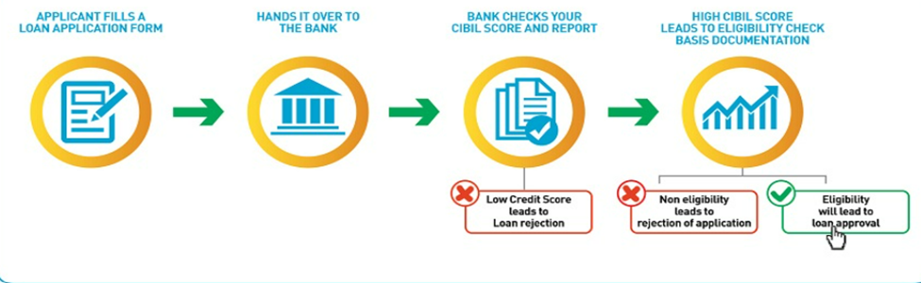

**3. RESULT**

There are many popular open sources for collecting the data. Eg: kaggle.com, UCI repository, etc.

In this project we have used .csv data. This data is downloaded from kaggle.com. Please refer to the link given below to download the dataset.

Link: <https://www.kaggle.com/datasets/altruistdelhite04/loan-prediction-problem-dataset>

.

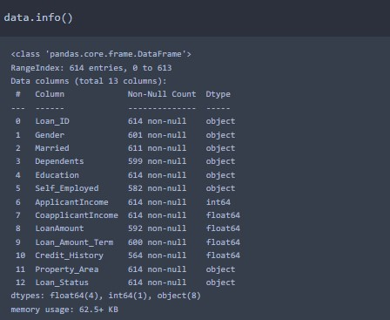

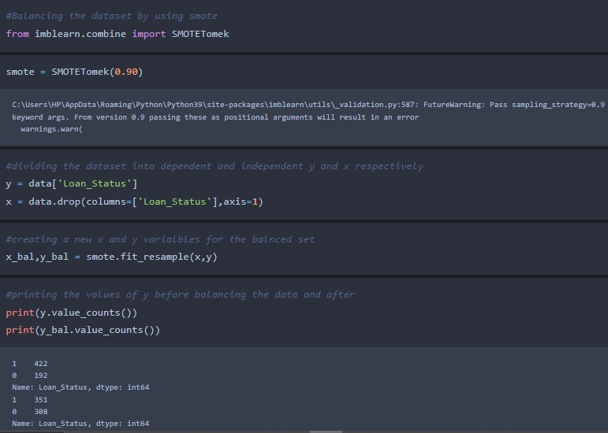

.

## Exploratory Data Analysis

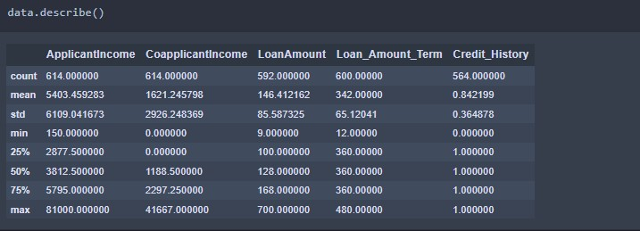

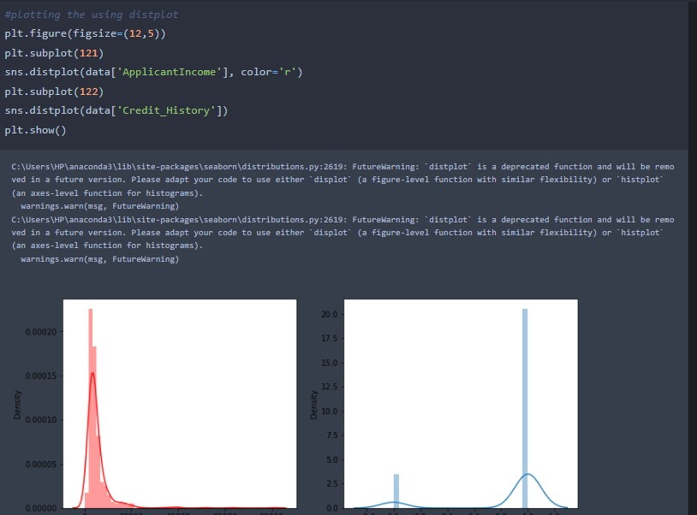

### Bivariate analysis

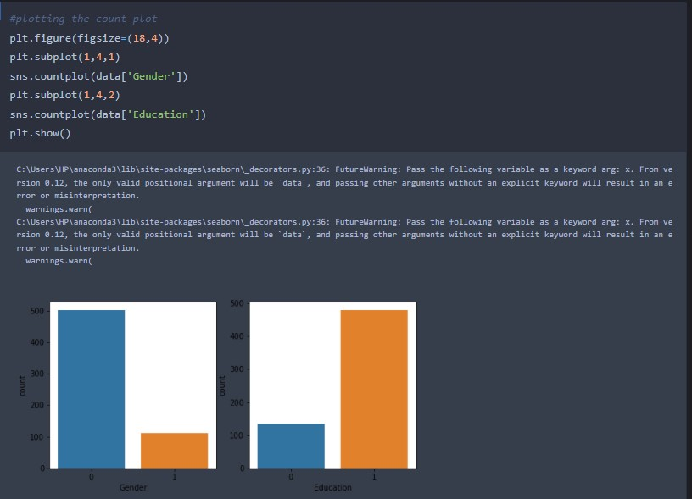

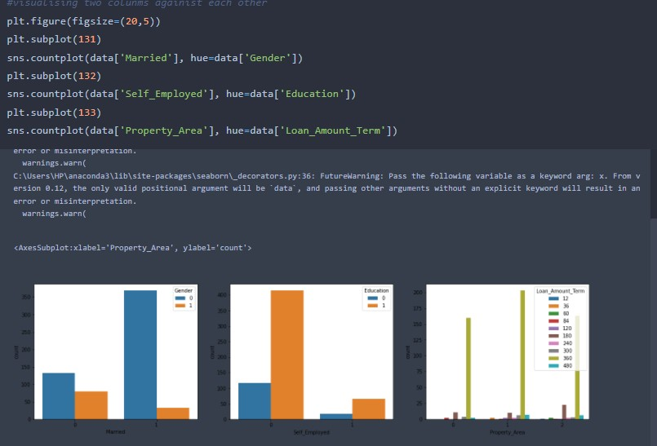

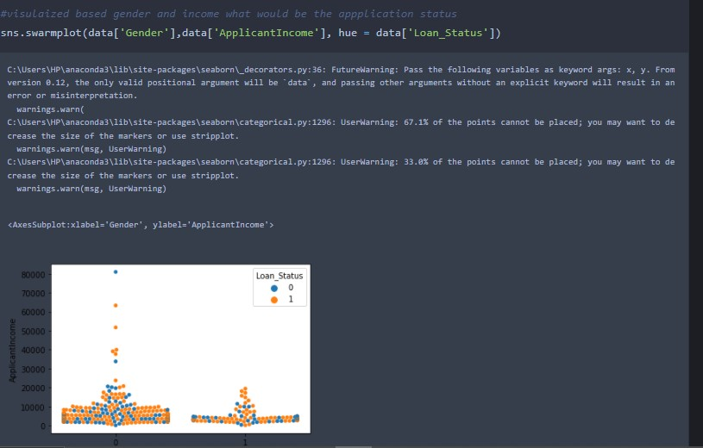

#### TRAIN AND TEST

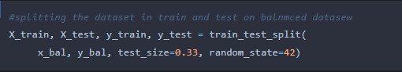

### Decision tree model

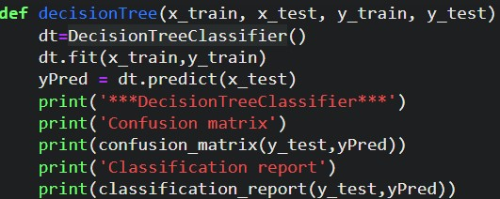

### KNN model

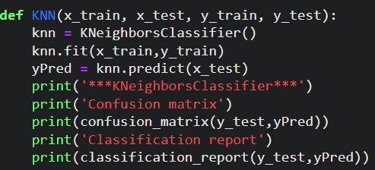

.

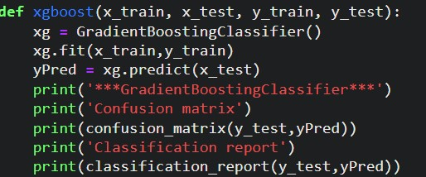

### ANN model

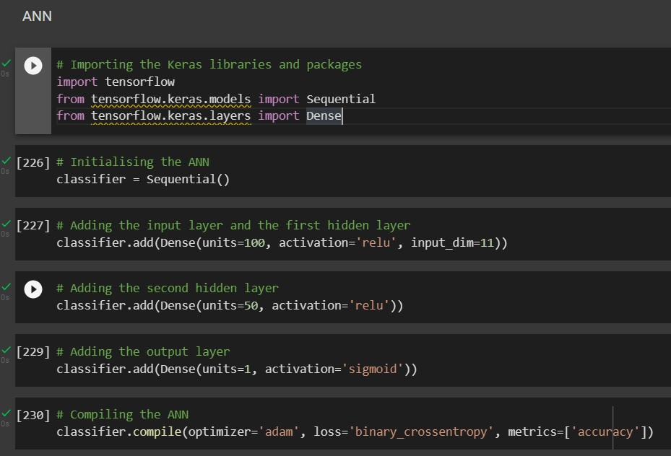

### Testing the model

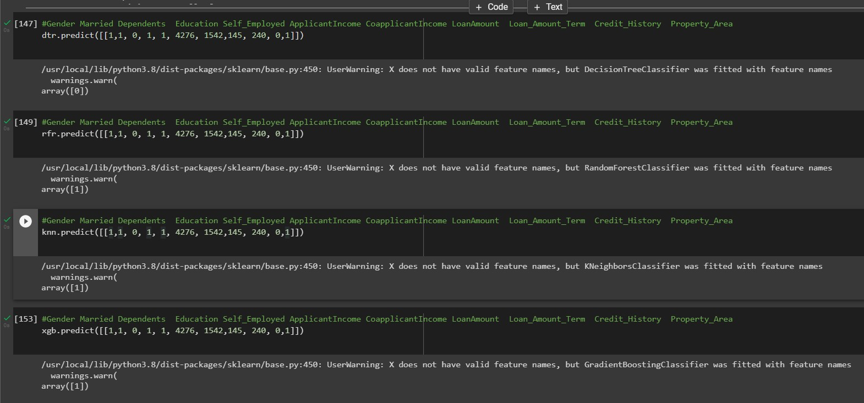

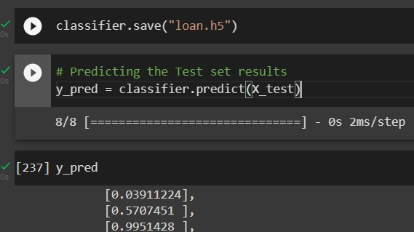

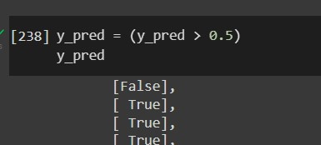

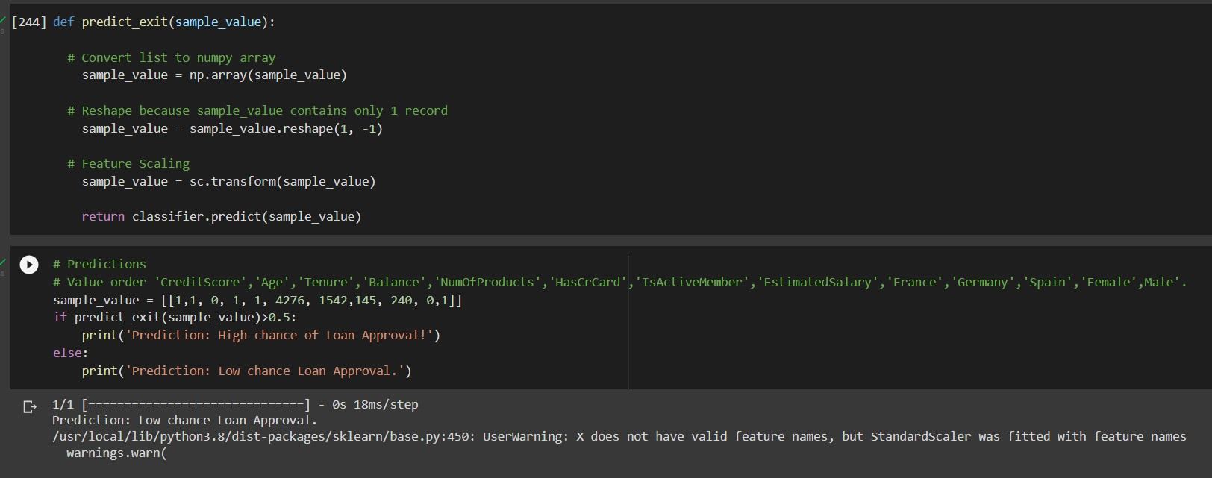

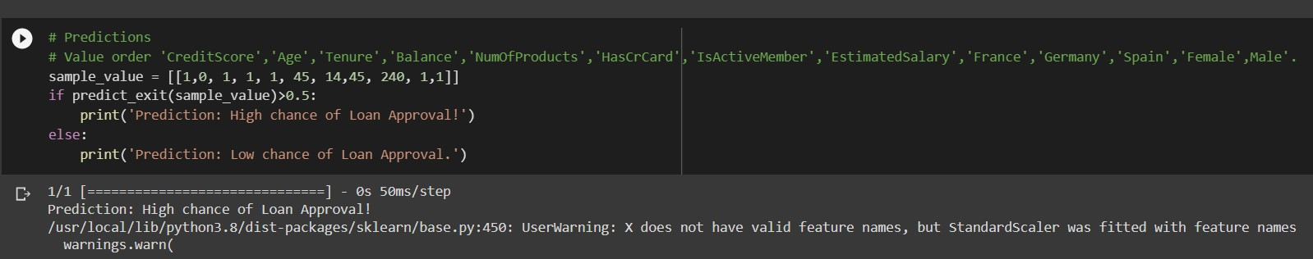

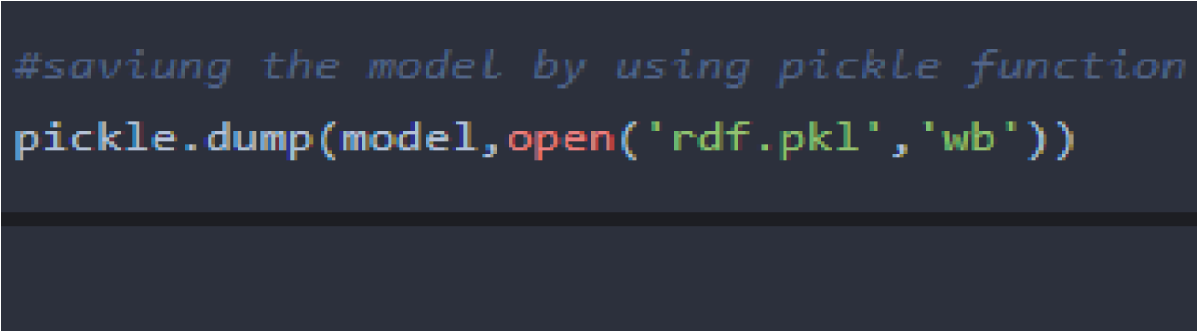

**Building Html Pages:**

For this project create two HTML files namely

* home.html
* predict.html and save them in the templates folder.

### OUTPUT:

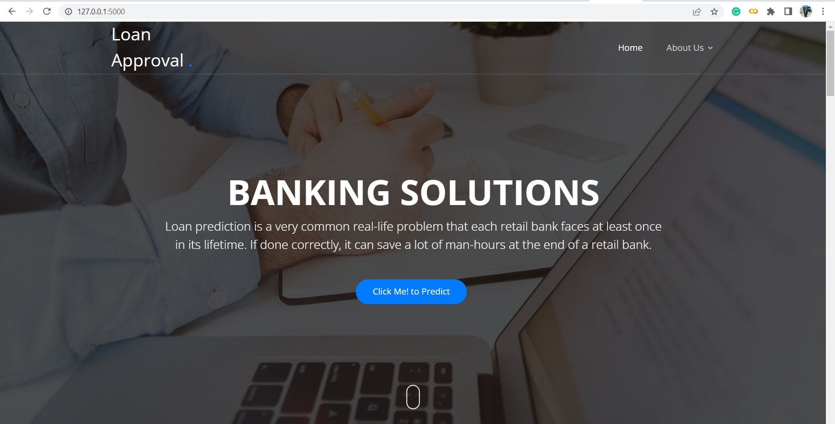

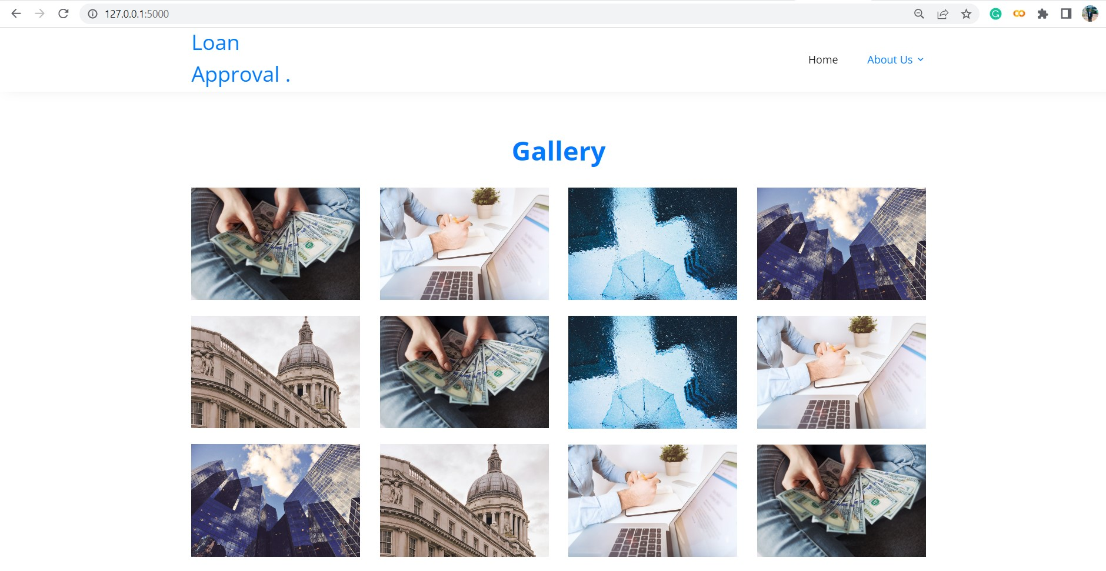

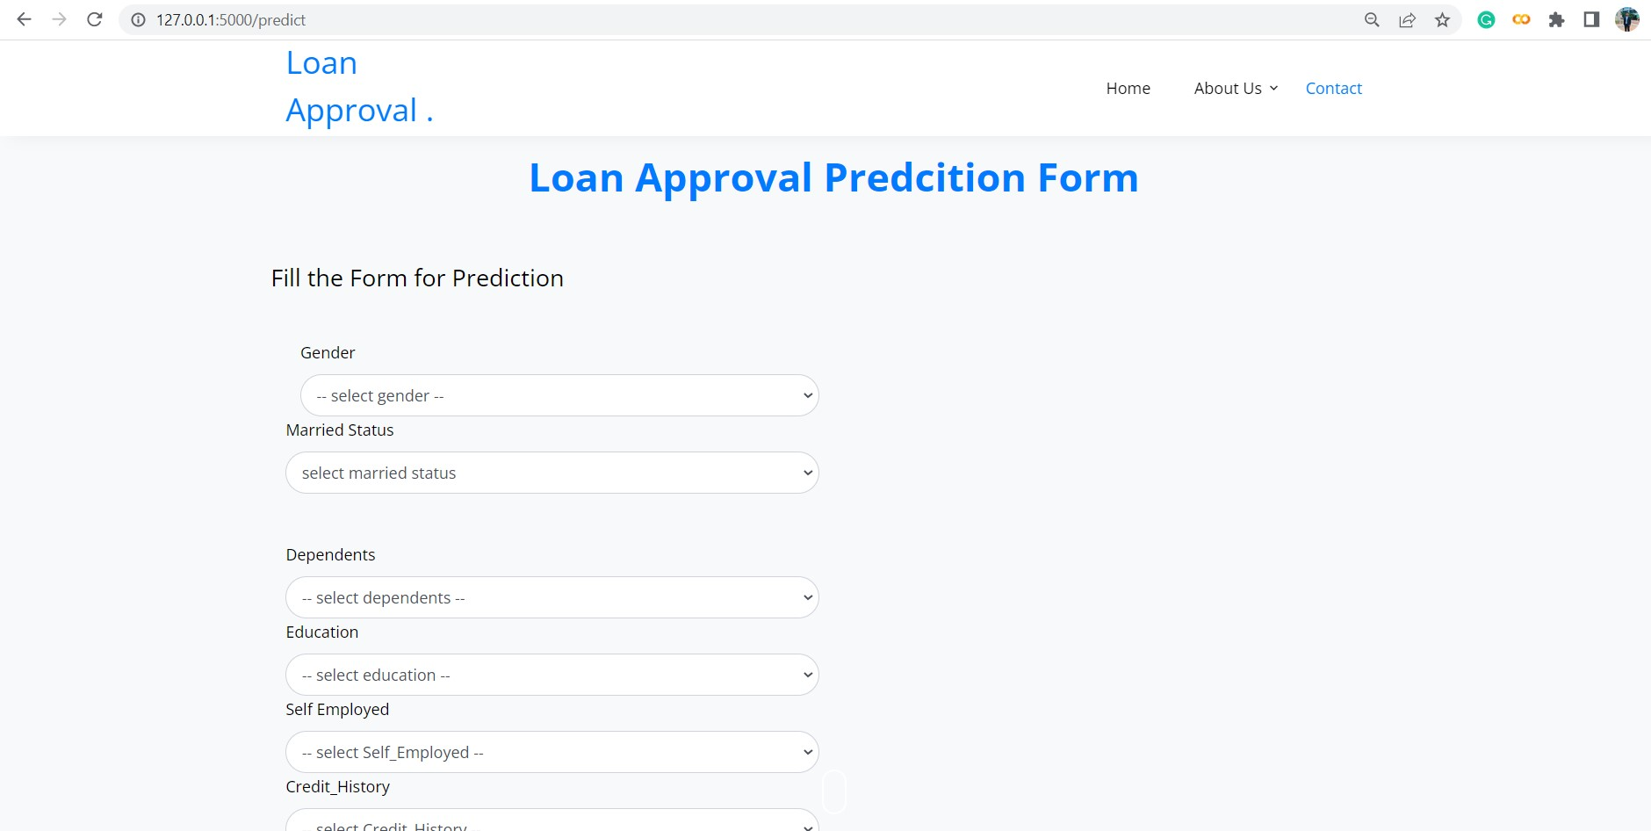

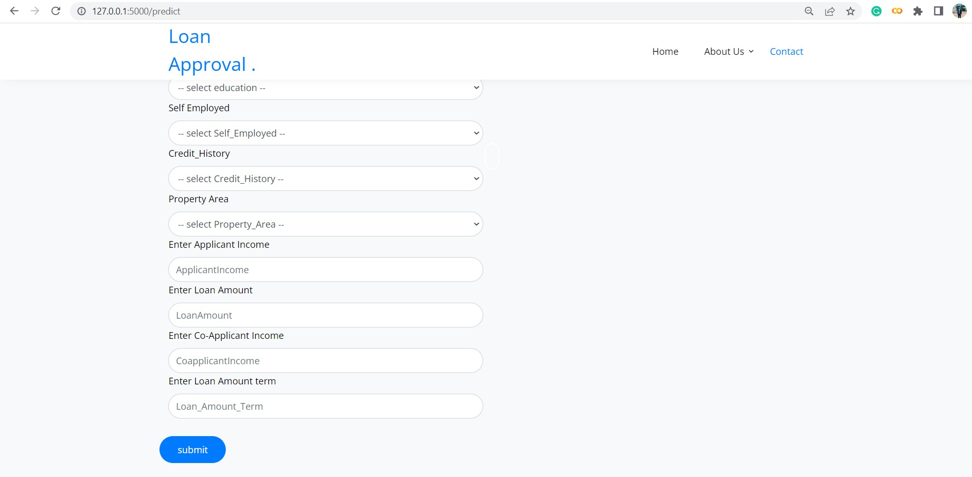

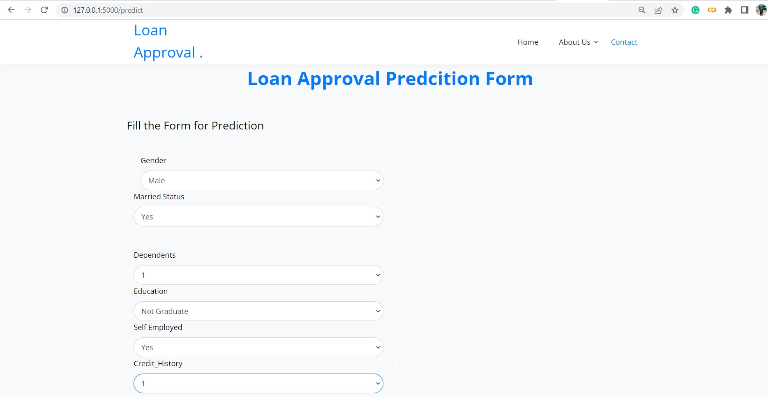

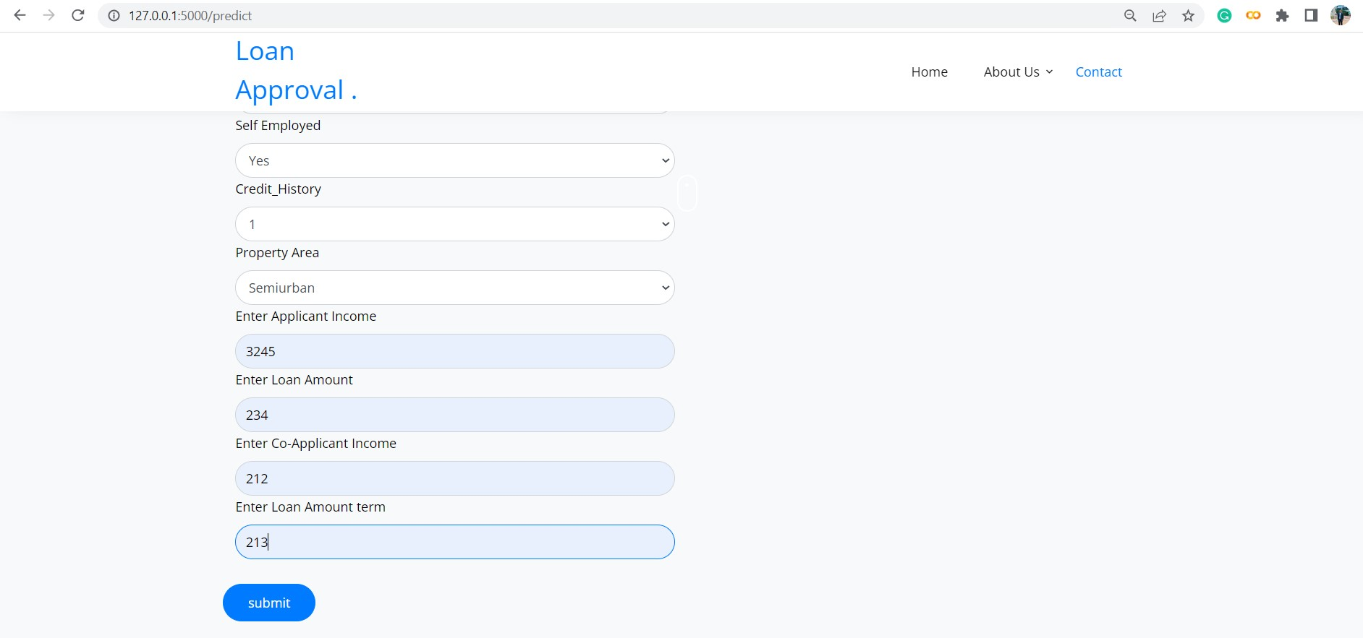 .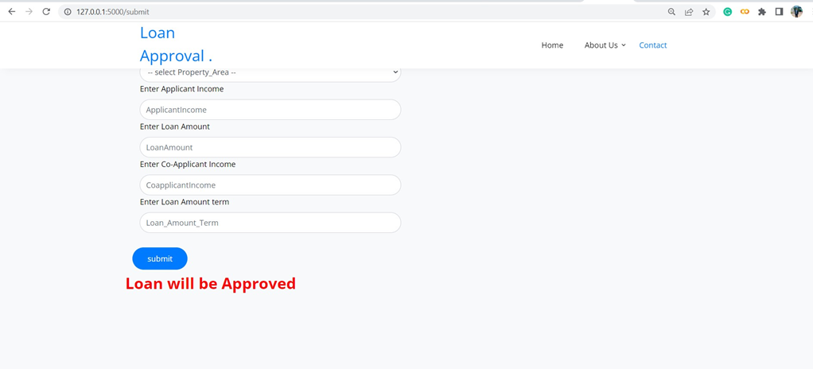

**4 ADVANTAGES & DISADVANTAGES**

### ADVANTAGES

* spread the cost of a significant purchase safely
* can help you manage your personal finances
* Ideal if you have struggled to save in the past
* Unsecured loans are not tied to assets

**DISADVANTAGES**

* Loan-term commitment
* Good product requires a good credit score
* Certain loan types are riskier than others
* Will never get 0% interest-unlike a credit card or finance deal

**5 APPLICATION**

* Check the eligibility criteria
* Check interest rates and other charges
* Calculate your EMI
* Check required documents
* Fill application form online
* Wait for loan approval

### 6 CONCLUSION

A system called loan credibility prediction system that helps the organization in making right decision to approve or reject the loan request of the customers

### 7 FUTURE SCOPE

The system is trained on old training dataset in future software can be made such that new testing data should also take part in training data after some fix time.

### 8 APPENDIX

Import the libraries

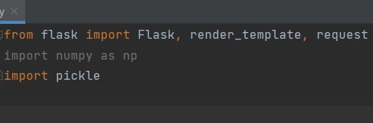

.



Render HTML page:

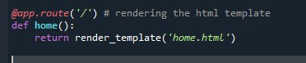

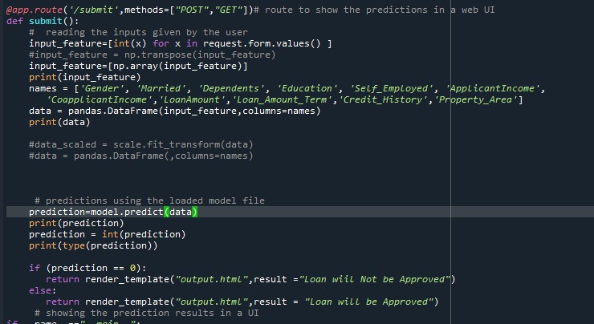

Main Function:

